**AWS (AMAZON WEB SERVICES)**

**INTRODUCTION**

**1. Cloud Computing:**

Cloud computing is the on-demand availability of computer system resources, especially data storage and computing power, without direct active management by the user. Large clouds often have functions distributed over multiple locations, each of which is a data center

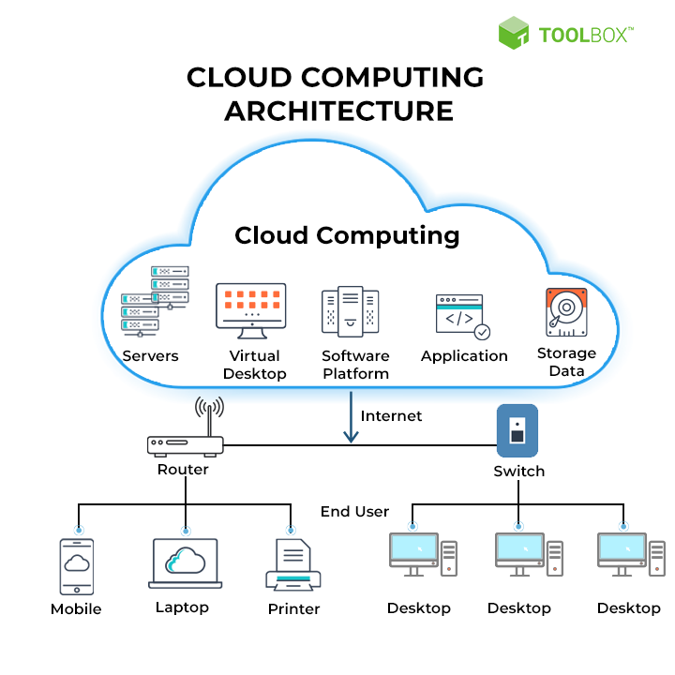

**2. Cloud Providers:**

The big three—Google Cloud, Microsoft Azure, and Amazon Web Services (AWS)—are considered the established leaders. However, there are a host of other smaller or niche players that offer cloud services as well, including IBM, Alibaba, Oracle, Red Hat, DigitalOcean, and Rackspace.

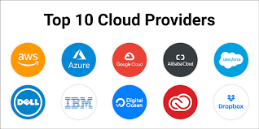

**3. Cloud Computing Deployment Models:**

The cloud deployment model identifies the specific type of cloud environment based on ownership, scale, and access, as well as the cloud’s nature and purpose. The location of the servers you’re utilizing and who controls them are defined by a cloud deployment model. It specifies how your cloud infrastructure will look, what you can change, and whether you will be given services or will have to create everything yourself. Relationships between the infrastructure and your users are also defined by cloud deployment types.

Different types of cloud computing deployment models are:

1. Public cloud
2. Private cloud
3. Hybrid cloud
4. Community cloud

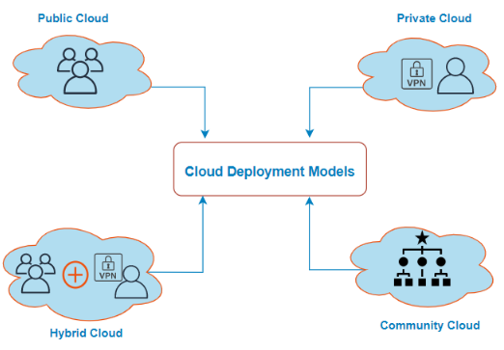

**A. Public Cloud**

The public cloud makes it possible for anybody to access systems and services.

 The public cloud is one in which cloud infrastructure services are provided over the internet to the general people or major industry groups. It is a type of cloud hosting that allows customers and users to easily access systems and services. In this arrangement, storage backup and retrieval services are given for free, as a subscription, or on a per-user basis. Example: Google App Engine etc.

**Advantages of Public Cloud Model:**

* **Minimal Investment:**Because it is a pay-per-use service, there is no substantial upfront fee, making it excellent for enterprises that require immediate access to resources.
* **No setup cost:** The entire infrastructure is fully subsidized by the cloud service providers, thus there is no need to set up any hardware.
* **Infrastructure Management is not required:**Using the public cloud does not necessitate infrastructure management.
* **No maintenance:**The maintenance work is done by the service provider (Not users).
* **Dynamic Scalability:** To fulfil your company’s needs, on-demand resources are accessible.

**Disadvantages of Public Cloud Model:**

* **Less secure:**Public cloud is less secure as resources are public so there is no guarantee of high-level security.
* **Low customization:**It is accessed by many public so it can’t be customized according to personal requirements.

**B. Private Cloud**

It’s a one-on-one environment for a single user (customer). There is no need to share your hardware with anyone else.  It is also called the “internal cloud” & it refers to the ability to access systems and services within a given border or organization. The cloud platform is implemented in a cloud-based secure environment that is protected by powerful firewalls and under the supervision of an organization’s IT department.

**Advantages of Private Cloud Model:**

* **Better Control:**You are the sole owner of the property. You gain complete command over service integration, IT operations, policies, and user behaviour.
* **Data Security and Privacy:** It’s suitable for storing corporate information to which only authorized staff have access. By segmenting resources within the same infrastructure, improved access and security can be achieved.
* **Supports Legacy Systems:** This approach is designed to work with legacy systems that are unable to access the public cloud.
* **Customization:**Unlike a public cloud deployment, a private cloud allows a company to tailor its solution to meet its specific needs.

**Disadvantages of Private Cloud Model:**

* **Less scalable:**Private clouds are scaled within a certain range as there is less number of clients.
* **Costly:** Private clouds are more costly as they provide personalized facilities.

**C. Hybrid Cloud**

By bridging the public and private worlds with a layer of proprietary software, hybrid cloud computing gives the best of both worlds. With a hybrid solution, you may host the app in a safe environment while taking advantage of the public cloud’s cost savings. Organizations can move data and applications between different clouds using a combination of two or more cloud deployment methods, depending on their needs.

**Advantages of Hybrid Cloud Model:**

* **Flexibility and control:**Businesses with more flexibility can design personalized solutions that meet their particular needs.
* **Cost:** Because public clouds provide scalability, you’ll only be responsible for paying for the extra capacity if you require it.
* **Security:**Because data is properly separated, the chances of data theft by attackers are considerably reduced.

**Disadvantages of Hybrid Cloud Model:**

* **Difficult to manage:**Hybrid clouds are difficult to manage as it is a combination of both public and private cloud. So, it is complex.
* **Slow data transmission:**Data transmission in the hybrid cloud takes place through the public cloud so latency occurs.

**D. Community Cloud**

It allows systems and services to be accessible by a group of organizations. It is a distributed system that is created by integrating the services of different clouds to address the specific needs of a community, industry, or business. The infrastructure of the community could be shared between the organization which has shared concerns or tasks. It is generally managed by a third party or by the combination of one or more organizations in the community.

**Advantages of Community Cloud Model:**

* **Cost Effective:**It is cost-effectivebecause the cloud is shared by multiple organizations or communities.
* **Security:** Community cloud provides better security.
* **Shared resources:**It allows you to share resources, infrastructure, etc. with multiple organizations.
* **Collaboration and data sharing:**It is suitable for both collaboration and data sharing.

**Disadvantages of Community Cloud Model:**

* **Limited Scalability:**Community cloud is relatively less scalable as many organizations share the same resources according to their collaborative interests.
* **Rigid in customization:**As the data and resources are shared among different organizations according to their mutual interests if an organization wants some changes according to their needs they cannot do so because it will have an impact on other organizations.

**4. Cloud Computing Services:**

There are the following three types of cloud service models -

**A. Infrastructure as a Service (IaaS)**

**B. Platform as a Service (PaaS)**

**C. Software as a Service (SaaS)**

## **A. Infrastructure as a Service (IaaS)**

IaaS is also known as **Hardware as a Service (HaaS)**. It is a computing infrastructure managed over the internet. The main advantage of using IaaS is that it helps users to avoid the cost and complexity of purchasing and managing the physical servers.

### Characteristics of IaaS:

There are the following characteristics of IaaS -

* Resources are available as a service
* Services are highly scalable
* Dynamic and flexible
* GUI and API-based access
* Automated administrative tasks

**Example:** DigitalOcean, Linode, Amazon Web Services (AWS), Microsoft Azure, Google Compute Engine (GCE), Rackspace, and Cisco Metacloud.

## **B. Platform as a Service (PaaS)**

PaaS cloud computing platform is created for the programmer to develop, test, run, and manage the applications.

### Characteristics of PaaS:

There are the following characteristics of PaaS -

* Accessible to various users via the same development application.
* Integrates with web services and databases.
* Builds on virtualization technology, so resources can easily be scaled up or down as per the organization's need.
* Support multiple languages and frameworks.
* Provides an ability to "**Auto-scale**".

**Example:** AWS Elastic Beanstalk, Windows Azure, Heroku, Force.com, Google App Engine, Apache Stratos, Magento Commerce Cloud, and OpenShift.

## **C. Software as a Service (SaaS)**

SaaS is also known as "**on-demand software**". It is a software in which the applications are hosted by a cloud service provider. Users can access these applications with the help of internet connection and web browser.

### Characteristics of SaaS:

There are the following characteristics of SaaS -

* Managed from a central location
* Hosted on a remote server
* Accessible over the internet
* Users are not responsible for hardware and software updates. Updates are applied automatically.
* The services are purchased on the pay-as-per-use basis

**Example:** BigCommerce, Google Apps, Salesforce, Dropbox, ZenDesk, Cisco WebEx, ZenDesk, Slack, and GoToMeeting.

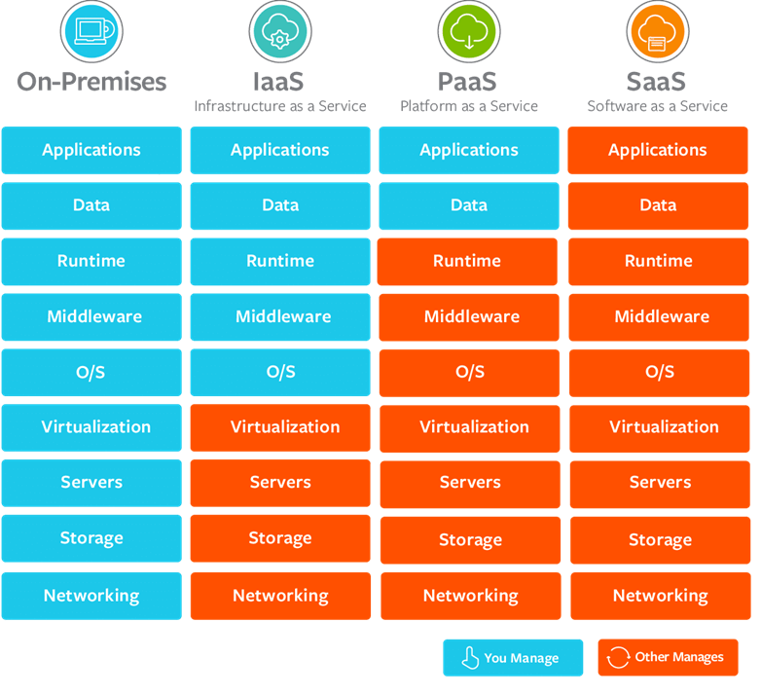

**5. AWS:**

AWS stands for Amazon Web Services which uses distributed IT infrastructure to provide different IT resources on demand. It provides different services such as infrastructure as a service (IaaS), platform as a service (PaaS) and packaged software as a service (SaaS). Amazon launched AWS, a cloud computing platform to allow the different organizations to take advantage of reliable IT infrastructure.

**Regions and Availability Zones:**

An AWS Region is a cluster of data centers in a specific geographic area, such as the Northeastern United States or Western Europe. It is a best practice to choose a region that is geographically close to users; this reduces latency because data reaches the users more quickly.

Each AWS Region includes multiple AZs. However, each AZ is restricted to a specific AWS Region. You can use multiple AZs within one Region, but you can't use the same AZ across multiple Regions.

An AZ is a standalone data center or set of data centers within a Region. Each AZ operates independently, so a failure in one won't affect others. In disaster recovery plans, enterprises use multiple AZs to increase redundancy and reliability.

| **Region name** | **Region code** | **Number of AZs** |
| --- | --- | --- |
| US East (Northern Virginia) | us-east-1 | 6 |
| US East (Ohio) | us-east-2 | 3 |
| US West (Oregon) | us-west-2 | 4 |
| US West (Northern California) | us-west-1 | 3 |
| AWS GovCloud (US-East) | us-gov-east-1 | 3 |
| AWS GovCloud (US-West) | us-gov-west-1 | 3 |
| Canada (Central) | ca-central-1 | 3 |
| South America (São Paulo) | sa-east-1 | 3 |
| Europe (Frankfurt) | eu-central-1 | 3 |
| Europe (Ireland) | eu-west-1 | 3 |
| Europe (London) | eu-west-2 | 3 |
| Europe (Milan) | eu-south-1 | 3 |
| Europe (Paris) | eu-west-3 | 3 |
| Europe (Stockholm) | eu-north-1 | 3 |
| Middle East (Bahrain) | me-south-1 | 3 |
| Africa (Cape Town) | af-south-1 | 3 |
| Asia Pacific (Hong Kong) | ap-east-1 | 3 |
| **Asia Pacific (Mumbai)** | **ap-south-1** | 3 |
| Asia Pacific (Seoul) | ap-northeast-2 | 4 |
| Asia Pacific (Singapore) | ap-southeast-1 | 3 |
| Asia Pacific (Sydney) | ap-southeast-2 | 3 |
| Asia Pacific (Tokyo) | ap-northeast-1 | 4 |
| Asia Pacific (Osaka) | ap-northeast-3 | 3 |
| Asia Pacific (Jakarta) | ap-southeast-3 | 3 |
| Mainland China (Beijing) | cn-north-1 | 3 |
| Mainland China (Ningxia) | cn-northwest-1 | 3 |

**6. NIST’s 5 Essential Cloud Computing Characteristics**

The **National Institute of Standards Technology** (NIST) lists five essential characteristics of cloud computing: on-demand self-service, broad network access, resource pooling, rapid elasticity, and measured service.

**A. On-Demand Self-Service**

With cloud computing, you can provision computing services, like server time and network storage, automatically. **You won’t need to interact with the service provider**. Cloud customers can access their cloud accounts through a web self-service portal to view their cloud services, monitor their usage, and provision and de-provision services.

**B. Broad Network Access**

Another essential cloud computing characteristic is broad network access. You can access cloud services over the network and on portable devices like mobile phones, tablets, laptops, and desktop computers. A public cloud uses the internet; a private cloud uses a local area network. **Latency and bandwidth both play a major role in cloud computing and broad network access**, as they affect the quality of service.

**C. Resource Pooling**

With resource pooling, **multiple customers can share physical resources using a multi-tenant** model. This model assigns and reassigns physical and virtual resources based on demand. Multi-tenancy allows customers to share the same applications or infrastructure while maintaining privacy and security. Though customers won't know the exact location of their resources, they may be able to specify the location at a higher level of abstraction, such as a country, state, or data center. Memory, processing, and bandwidth are among the resources that customers can pool.

**D. Rapid Elasticity**

Cloud services can be elastically provisioned and released, sometimes automatically, so customers can **scale quickly based on demand**. The capabilities available for provisioning are practically unlimited. Customers can engage with these capabilities at any time in any quantity. Customers can also scale cloud use, capacity, and cost without extra contracts or fees. With rapid elasticity, you won’t need to buy computer hardware. Instead, can use the cloud provider's cloud computing resources.

**E. Measured Service:**

In cloud systems, a metering capability optimizes resource usage at a level of abstraction appropriate to the type of service. For example, you can use a measured service for storage, processing, bandwidth, and users. **Payment is based on actual consumption by the customer via a pay-for-what-you-use model**. Monitoring, controlling, and reporting resource use creates a transparent experience for both consumers and providers of the service.

**Other Cloud Computing Characteristics:**

While not among the NIST essential characteristics, cloud computing offers a variety of other characteristics that can benefit customers.

**F. Resiliency and Availability**

Resilience in cloud computing refers to the ability of a service to **recover quickly from any disruption**. Cloud resiliency is measured by how fast its servers, databases, and networks restart and recover after any damage. To prevent data loss, cloud services create a copy of the stored data. If one server loses data for any reason, the copy version from the other server restores.

Availability is a related key concept in cloud computing. The benefit of cloud services is that you can access them remotely, so there are **no geographic restrictions** when using cloud resources.

**G. Flexibility**

Companies need to scale as their business grows. **The cloud provides customers with more freedom to scale as they please without restarting the server**. They can also choose from several payment options to avoid overspending on resources they won't need.

**H. Remote Work**

**Cloud computing helps users work remotely.** Remote workers can safely and quickly access corporate data via their devices, including laptops and smartphones. Employees who work remotely can also communicate with each other and perform their jobs effectively using the cloud.

**FAQS:**

1. What is Cloud Computing and Explain Advantages?
2. Explain Deployment models in Cloud Computing?
3. What is SAAS, PAAS and IAAS?
4. What are different characteristics of cloud computing?
5. Explain AWS Regions and AZs?
6. Write some AWS service names?